KARATE WEB APPLICATION

**Introduction**

Karate Web Application is created using Django. Django is a high-level Python web framework that encourages rapid development and clean, pragmatic design. Django was designed to help the developers to take applications from concept to completion as quickly as possible. It takes security seriously and helps to avoid the common security mistakes.

Django is a Python framework that makes it easier to create web sites using Python. It takes care of the difficult stuff so that you can concentrate on building the web applications. It emphasizes the reusability of components and comes with ready-to-use features like login system, database connection, etc.

The important key features that we provided for this web application are:

* Super Login (Admin)
* Multiuser Authentication.
* Secure.
* Scalable.
* Maintainable.

This web application interface is created using Basic HTML, Bootstrap, CSS and JavaScript.

Frame work: Django.

Back End: MySQL.

Modules:

1. ADMIN.
2. USER.

Features provided in Admin Panel:

* Admin Login.
* Password reset.
* Admin Dashboard.
* Add & edit gallery folder.
* Add & edit blackbelt-holders category.
* Add affiliation form category.
* Add & edit Carousel.
* Video insertion.

Features provided in User Panel:

* User homepage.
* About.
* Gallery.
* Contact.
* View blackbelt-holders.
* View affiliation form.

Common links and scripts tags used here are:

Links.

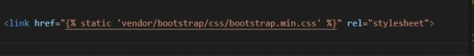

Script tags.

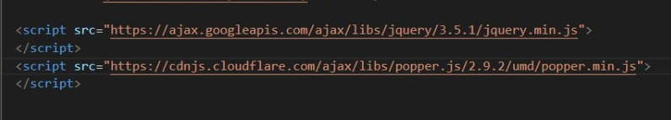

MySQL Database Tables:

1. Carousel.
2. Affiliation.
3. Image folder.
4. Images.
5. Blackbelt holders.
6. Videos.

Table Fields:

Carousel

1. Carousel image.
2. Title.
3. Subtitle.

Affiliation

1. Affiliation name.
2. Affiliation image.

Image Folder.

1. Folder name.

Images.

1. Image.
2. Folder id.

Blackbelt holder

1. Register number.
2. Name.
3. Designation.
4. Image.

Videos

1. Video link.

Django MySQL Database Connection.

Settings.py.

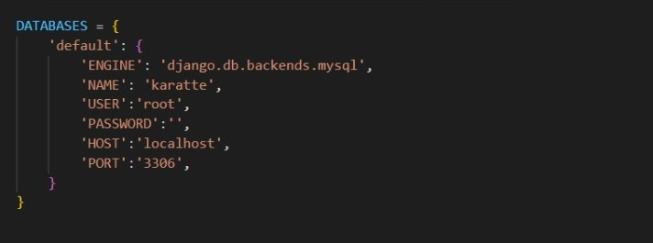

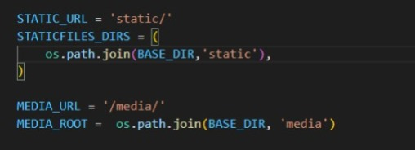

Install app in settings.py:

